[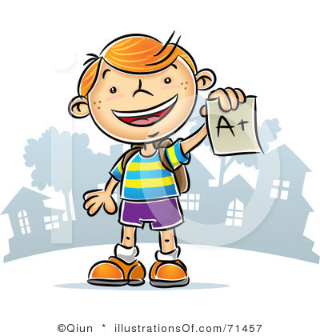](http://www.clipartpanda.com/clipart_images/rf-student-clipart-31045501)[](http://www.clipartpanda.com/clipart_images/rf-student-clipart-31045501)

Welcome to Class 112

Dear Parent(s)/Guardian,

I am grateful to have your child in my class this year! I am excited to not only get to know your child, but you as well. Having parental/guardian support and communication is very important to me and your child. Thank you for everything you do for your child and the school!

Dear Students,

I Believe in YOU

I Trust in YOU

YOU are Listened To

YOU are Cared For

YOU are Important

YOU WILL SUCCEED!

Keep up to date on room 112 with videos of activities at: http://teachinginroom6.blogspot.com/